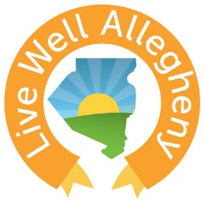
Live Well Allegheny:
2018 Learning Collaborative Series

Stress Management & Health
Monday, March 12th ∙ 2:00 – 4:30PM
Hosanna House Event Center
807 Wallace Avenue, 3rd Floor, Pittsburgh, PA 15221

Meeting Objectives
Empower members with tools, resources, and success stories that they can use to encourage and enable healthy choices.
Unite members to recognize the potential in their communities to achieve the goal of making Allegheny County the healthiest county.
Ignite Live Well Allegheny leaders to be change makers in their communities.

Agenda
Opening: Live Well Allegheny, Hannah Hardy

Session #1: Stress & Health
How Stress Impacts your Health: Lorraine Starsky, BSN, RN, Allegheny County Health Department
The Stress of Trauma – Impacts on Health: Taili Thompson, Allegheny County Health Department & Rev. Paul Abernathy, FOCUS Pittsburgh

Session #2: Ways to Manage Stress
Mindfulness: Richard King, PhD, Mindful Pittsburgh

Session #3: Live Well Allegheny Partner Highlight
Yoga & Grief: Connie Tinsley, Borough of Turtle Creek

Wrap Up & Networking Opportunity

