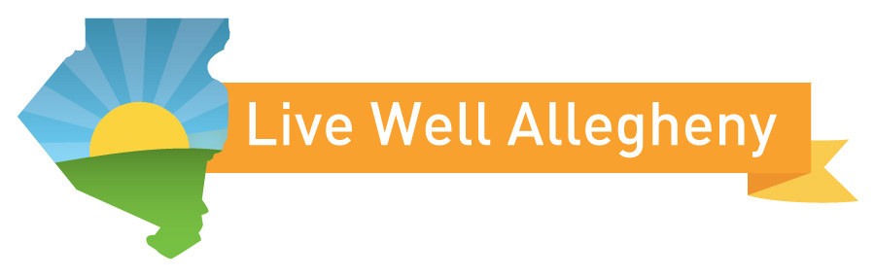

Blurb to introduce Live Well Allegheny participation

We are proud to be a part of the Live Well Allegheny campaign. The Live Well Allegheny Campaign aims to improve the health and well-being of Allegheny County residents through a collaborative effort that involves multiple stakeholders, partners and residents. You can follow social media updates for the campaign using the hashtag #LiveWellAllegheny.

[if you have a page on your website about your participation in live Well Allegheny hyperlink to that page from this blurb or if printed include the URL]

Blurb to promote a Live Well Allegheny event

Join us at [insert event name], a Live Well Allegheny event.
[Insert event details]

Live Well Allegheny provides communities with information about screenings, fitness activities, healthy cooking demonstrations, tips on stress management and other activities geared to residents of all ages. To find out about more Live Well events happening near you visit www.LiveWellAllegheny.com

