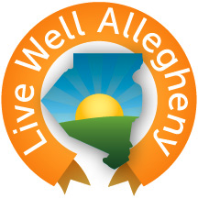

(your logo here)

FOR IMMEDIATE RELEASE  (add date here) | CONTACT: | Your Press Contact Here  Melissa Wade  Public Health Information Officer  412-578-8312  mwade@achd.net

Your Headline Here

Your Community Name Here – (start your press release)

(content to use in your press release)
Live Well Allegheny was launched in January 2014 as a comprehensive, innovative strategy on wellness that embraces a broad concept of living well to include physical health, mental wellness, personal and community safety, prevention and preparedness, and much more. The effort is being led by the Board of Health and Health Department Director Dr. Karen Hacker.

(draft quote to use in press release)
We’re very excited to see the Live Well Allegheny program gaining some significant traction,” said Dr. Karen Hacker, Director of the Allegheny County Health Department. “Our stakeholders, partners, schools and communities continue to be excited about this initiative and are constantly working to find more ways to help our residents become healthier. I have no doubt that, working together, we can have a real impact on our county’s health.”

(footer content to use in your press release)
For more information on the Live Well Allegheny campaign, including how to become a Live Well Allegheny school, visit www.LiveWellAllegheny.com.

# # #

