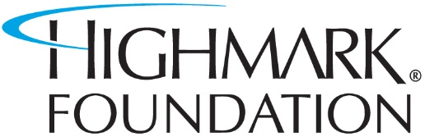
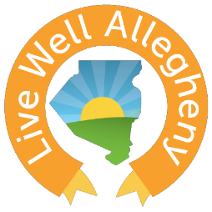
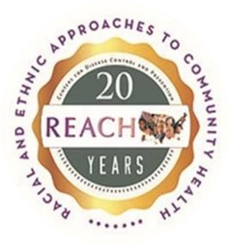

LWA² Community Health Fund Application

General Information
Applicant Organization:
Address:
City:
State:
Zip:
Project Title:
Contact Name:
Contact Number:
Contact Email:

- What type institution is the applicant organization?
  - Community-Based
  - Educational Institution
  - Faith-Based Organization
  - Professional Association
  - Clinic/Hospital
  - Other

- What Priority Community/Communities will your proposed activities primarily serve (check all that apply)?
  - Hill
  - Northside
  - Larimer/East Hills/Homewood
  - Wilkinsburg
  - Garfield
  - Mon Valley Community (please specify)

- What Strategy(ies) are you most interested in?
  - Nutrition
  - Physical Activity
  - Community Clinical Linkage

- Please describe your organization’s goals and provide an example(s) of how you have engaged community members in your work: (500-word MAX)

- Please outline your proposed activities and budget (not to exceed 9,999):

- What is the timeline for your proposed activities (Please specify the # of months)?

- How can the work you are already doing in your organization/community benefit the REACH grant? Please be specific. (500-word MAX)

