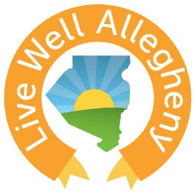
Live Well Allegheny:
2018 Learning Collaborative Series

How to Live Well in your Environment
Tuesday, June 5th ∙ 5:00 – 7:30PM
Frick Environmental Center
2005 Beechwood Blvd, Pittsburgh, PA 15217

Meeting Objectives
Empower members with tools, resources, and success stories that they can use to encourage and enable healthy choices.
Unite members to recognize the potential in their communities to achieve the goal of making Allegheny County the healthiest county.
Ignite Live Well Allegheny leaders to be change makers in their communities.

Agenda
Opening: Live Well Allegheny, Hannah Hardy

Session #1: Environmental Considerations to Health: Lead
ACHD’s Approach to Lead: Megan Tulikangas, Allegheny County Health Department

Break

Session #2: World Café Roundtables
Gardening & Soil Testing: Rayden Sorock, Grow Pittsburgh
Improving Indoor Air Quality/Safe Cleaning Products: Michele Buford, Women for a Healthy Environment
Preventing Tick Bites & Vector-Borne Illnesses: Leah Lamonte, Allegheny County Health Department

Wrap Up & Networking Opportunity

