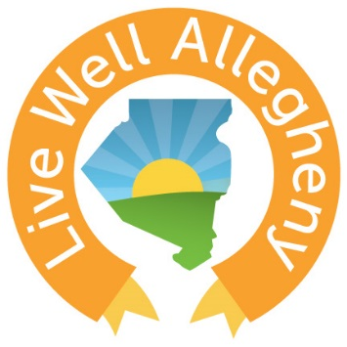
Live Well Allegheny:
Learning Collaborative Event
  - January 10th, 2017
8:30-12:00pm

Meeting Objectives
Unite members to recognize the potential in their communities to achieve the goal of making Allegheny County the healthiest county.
Empower members with tools, resources, and success stories that they can use to encourage and enable healthy choices.
Ignite Live Well Allegheny leaders to be change makers in their communities.

Agenda
8:30-9:00am Registration & Breakfast Served
9:00-10:00am Session #1: Setting the Stage
Introduction, Dr. Karen Hacker
Health in All Policies Presentation
Personal Testimony, Chris Edmonds from #ATU
10:00-11:00am Session #2: How are We Living Well Today?
Live Well Allegheny Participant Panel
11:00-12:00pm Session #3: Living Well into the Future
Activity 1: In a learning collaborative, I value…
Activity 2: Future Cover Story
Wrap Up & Networking Opportunity

